29th June 2017

Single-use diaphragm valve established on the market

In future, there will be a larger selection of versions of the world's first controllable single-use diaphragm valve – GEMÜ SUMONDO.

GEMÜ, the leading manufacturer of valve designs for the pharmaceutical industry, has established the first controllable single-use diaphragm valve on the market – the GEMÜ SUMONDO. In addition to a pneumatically operated version, the product range also includes a version with a handwheel for manual operation.

Due to increasing customer demand, the range has been expanded in the area of associated valve bodies. With a third diaphragm size, another high-performance member has been added to the product range: The largest valve of its type to-date, with up to 1". This means that applications can be handled for which higher medium flows and precise controllability are indispensable.

Produced and packaged in the cleanroom, the single-use valves comply with all requirements for pharmaceutical processes. Yet the application possibilities do not stop there. In other areas too, such as in research centres and laboratory facilities, the valves become a cost-efficient and, above all, safe solution. The risk of cross contamination is considerably reduced, cleaning costs are significantly reduced, and plant downtimes are reduced to a minimum. Even with smaller batches and more frequent changes of media, the advantages of the SUMONDO valve quickly become apparent and prove themselves in terms of cost.

The GEMÜ single-use solution outperforms conventional pinch valve systems in a large number of cases. The controllability becomes considerably more precise, and the flow rates remain constant even with intensive use. With GEMÜ SUMONDO, it becomes possible to implement entirely new process functions in single-use applications – functions that could not be implemented with conventional systems. This includes processes for mixing, dosing and distributing media or controlling the transmembrane pressure in a plant. And this is always precise, reproducible and, if required, also automated – thanks to a pneumatic actuator. Alternatively, the manual actuator is of course retained and, with a robust plastic handwheel and definable stroke, it guarantees reliable opening, closing and precise setting of the volumetric flow.

The underlying idea of the SUMONDO valve can be summarized as follows: A valve body for single use and an actuator for repeated use. With this combination, the foundation is laid for cost-effective processes of the highest quality. The optional instrumentation completes this valve solution and makes it intelligent. This means that, thanks to GEMÜ's modular system, various positioners and process controllers can be easily integrated.

If you look at the outside of the valve, you notice that some new connection sizes with various connection types are available. These range from 1/4" to 1", from the clamp connection to the hose barb. Both for new and existing systems, this offers the operator completely new opportunities: A more flexible system design and a wider scope of controllability – with flow rates of 0.5 m³/h to 12 m³/h.

However, it is not just the outside of the valve that has changed – innovative developments inside the valve have produced something from which the user can benefit: The optimized seat contour and the modified diaphragm material will, in future, guarantee the usual perfect fit, maximum tightness and an even longer useful life for the valve body.

The requirements and demands placed on the plant design will also increase in the future. With GEMÜ SUMONDO, the operators of single-use systems already have a future-proof solution at their disposal – one that impresses thanks to its safety, quality and efficiency.

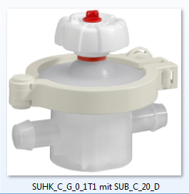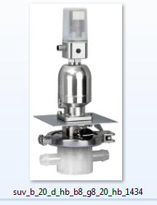
SUMONDO manually operated SUMONDO with pneumatic actuator and GEMÜ 1434 controller

Background information
GEMÜ is one of the world's leading manufacturers of valves, measurement and control systems. Over the course of more than 50 years, this globally focused, independent family owned enterprise has established itself in important industrial sectors thanks to its innovative products and customised solutions for process media control. GEMÜ is the world market leader for sterile valve applications in the pharmaceutical and biotechnology industries.
Today, the GEMÜ Group employs over 900 employees in Germany and more than 1600 worldwide. Manufacturing is carried out at six manufacturing sites in Germany, Switzerland, China, Brazil, France and the USA. From Germany we coordinate global marketing with 27 subsidiaries and with a large distributor network in more than 50 countries, the GEMÜ Group is active on all five continents. GEMÜ will continue to establish itself in future markets with its international growth strategy.
A broad based modular system and adapted automation components mean that individualised standard products and customised solutions can be combined to make over 400,000 product versions.
Further information can be found at www.gemu-group.com.

