Compact combi switchboxes with high air output

GEMÜ, a manufacturer of solutions for valves, measurement and control systems, has adapted its range of products in the area of combi switchboxes.
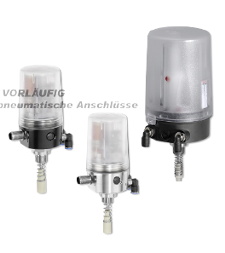
With the addition of two new product types and the adaptation of an existing type, the company completes its product range and thereby offers its customers an even more customized selection. This enables a combi switchbox to be selected which is even better adapted to specific requirements.
In comparison to external types, the integrated pilot valve offers both functional and cost benefits, such as fast reaction times, automatic programming of end positions and lower compressed air consumption. GEMÜ combi switchboxes therefore not only enable precise position detection, they also provide efficient activation of the respective process valve.
With immediate effect, the GEMÜ 4242 combi switchbox is also available with an increased air output, which means that it is possible to equip valves with a stroke of 2 to 75 mm with this product. The new size also comes with the same well-known features. This includes a high visibility display and position indicator, various interfaces such as AS-Interface, DeviceNet, IO-Link and 24V, as well as fast commissioning using automatic end position programming, both on-site and externally. Detailed diagnosis options make operation easier and simplify fault analysis.
Both new GEMÜ 4240 and GEMÜ 4241 types work with mechanically adjustable sensors and offer a cost effective alternative compared to versions with electronic position detection. On the GEMÜ 4240, either microswitches or proximity switches enable the monitoring of valve end positions. On the GEMÜ 4241, this is likewise implemented using the above-mentioned technology. The proximity switches can be adjusted quickly and safely using a grid adjustment. In addition, this product type offers explosion protection approval in accordance with ATEX.
All combi switchboxes have a manual override to enable the activation of the valve without electronic support. This is especially helpful when performing servicing work.

Caption: GEMÜ 4242 combi switchbox (various versions)

