Safe media supply due to anti-static plant components

Electrically conductive designs of the GEMÜ PC50 iComLine multi-port valve blocks and the GEMÜ TubeStar tubes allow for the safe operation of plants, even with highly flammable media.

Plastics as valve material have an ever wider range of uses in the processing industries. Because of their good chemical and mechanical resistance, they are being used more and more frequently in processing corrosive media such as slurry. Even in solvent supply, the trend is increasingly toward the use of high-performance thermoplastics.
The handling of corrosive or highly flammable media such as solvents is risky because they are conducive to electro-static build-up and the development of flammable vapours. Uncontrolled and sudden discharge can ignite entire plants. Not only safeguarding against shortfalls but also ensuring the safety of the operating personnel is in focus during operation of the plants.
Conductive multi-port valve blocks of the GEMÜ PC50 iComLine series and GEMÜ TubeStar tubes reduce the risk of any such ignition to a minimum. Carbon is added to the fluoropolymer during the production process to make the components conductive and to discharge the electro-static build-up specifically over these conductive components.
GEMÜ designs the specified multi-port valve blocks on a case-by-case basis and manufactures them according to customer requirement. The conductive valve body made of PTFE makes it possible to combine various connections in different nominal sizes with each other. In addition, manual or pneumatic actuator versions and sensor systems can be integrated optionally.
The GEMÜ PC50 iComLine multi-port valve blocks can be safely operated in the conductive design at an operating pressure of 4.2 bar and ensure an optimal capability to dissipate electro-static charges in conjunction with the conductive GEMÜ TubeStar tubes. The conductivity ranges between 10⁵ and 10⁸ ohms. The tubes referred to are available made of PFA and PTFE material. On request, the version made of PTFE can also be offered as an FDA-compliant design. The tubes made of perfluoroalkoxy (PFA) are available in both media-wetted and non-media-wetted design. The media-wetted version is black and non-transparent due to its carbon content like the multi-port valve blocks themselves. In the non-media-wetted design, a special procedure introduces a conductive strip to the surface only. This makes it possible to monitor the medium inside the tube visually on the one hand and ensures a high degree of freedom from particles on the other because the medium comes in contact only with the ultra-pure PFA. The anti-static tubes are available in sizes from 1/4“ to 1 ¼ “. Further sizes or wall thicknesses are available according to customer requirements.

Conductive GEMÜ TubeStar, non-media-wetted design
Conductive GEMÜ TubeStar, media-wetted design

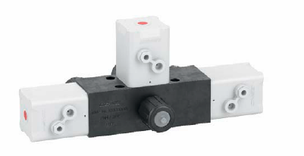
Sample configuration of GEMÜ PC50 iComLine, conductive design

