28th February 2018

Plant servicing, device service and training made easy

Support for the instrumentation of process valves and the initialization of electronic valve attachments.

The new GEMÜ PLC-based multifunctional case is used for operating (independently of plants), programming and initializing the automated devices mounted on the process valves. This includes, for example, electrical position indicators, combi switchboxes and electronic and electro-pneumatic positioners. The multifunction device is tuned to suit GEMÜ automation technology in particular. However, devices and products from other manufacturers can also be connected to it. To this end, the case also has freely selectable 0–10 V, 0–20 mA and 4–20 mA input/output signals as well as a 24 V/DC device supply system and an Ethernet interface as standard. Sensors and measuring transducers can also communicate with the device. The multifunctional case is also suitable for training technical personnel, e.g. for maintenance and plant servicing. The device is compact, optimized for frequent transport and designed to be especially robust. It is guaranteed to be safe to operate, even by inexperienced people. The GEMÜ measurement and control systems functional case has a Siemens programmable logic control unit (PLC) and is equipped with an industrial touchscreen display. The clear graphic display design ensures intuitive operation, even for inexperienced users. Eight languages can be freely selected on the homepage, enabling international usage (D, GB, F, S, RUS, ES, BR, IT). A small compressor as well as a pressure accumulator are integrated into the functional case – this makes the independent pneumatic air supply to connected devices of small to medium nominal size possible. Overloading the user interface with unnecessary information was deliberately avoided. The display design is therefore clear and it is easy for the operator to orient themselves in the menu. The functional case is supplied with the pre-assembled cables required for operation with GEMÜ products as standard. To operate devices from other manufacturers, cables can be optionally provided. The measurement and control systems case works with an operating voltage of 100 V/AC to 240 V/AC and can therefore be used with all common mains supply networks all over the world. The stable TANOS case system made of ABS was selected to make up the body and for transport. The cases can be safely stacked and can interlock.
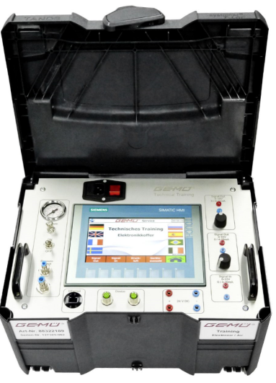
Caption:
Clear, intuitive to operate, multifunctional and suitable for mobile use. With these qualities, the GEMÜ measurement and control systems functional case provides practical support to plant designers, service employees and for technical personnel training.

Background information
GEMÜ is one of the world's leading manufacturers of valves, measurement and control systems. Over the course of more than 50 years, this globally focused, independent family owned enterprise has established itself in important industrial sectors thanks to its innovative products and customised solutions for process media control. GEMÜ is the world market leader for sterile valve applications in the pharmaceutical and biotechnology industries.
Today, the GEMÜ Group employs over 1000 employees in Germany and more than 1700 worldwide. Manufacturing is carried out at six manufacturing sites in Germany, Switzerland, China, Brazil, France and the USA. From Germany we coordinate global marketing with 26 subsidiaries and with a large distributor network in more than 50 countries, the GEMÜ Group is active on all five continents. GEMÜ will continue to establish itself in future markets with its international growth strategy.
A broad based modular system and adapted automation components mean that individualised standard products and customised solutions can be combined to make over 400,000 product versions.
Further information can be found at www.gemu-group.com

