20th October 2020

New GEMÜ GDR and GSR actuators for pneumatically operated quarter turn valves

The valve specialist GEMÜ is expanding its range of pneumatically operated butterfly valves and ball valves, and will also offer versions with simple GEMÜ GDR or GSR basic actuators in the future.
The GEMÜ GDR and GSR basic actuators are available for pneumatically operated butterfly valves and ball valves. The single acting design of GEMÜ GSR and the double acting design of GEMÜ GDR are suited to simple open/close applications in non-corrosive environments. The setting range for the end positions ± 5°. The actuators can be operated with a control pressure of 2.5 bar minimum and 8 bar maximum, and are suited to low to medium cycle duties. The optical position is indicated via a trigger cam with scale ring, allowing the position of the butterfly disc in the piping to be determined quickly and easily.
The standardized flanged connection according to DIN EN ISO 5211 from F03 to F14 enables quick and easy fitting onto GEMÜ quarter turn valves with nominal sizes up to DN 350 maximum. The actuators also feature an interface according to VDI/VDE3845 for position indicators, pilot valves and other accessories. Because of the aluminium housing and the epoxy-coated cover, actuators are protected against corrosion.
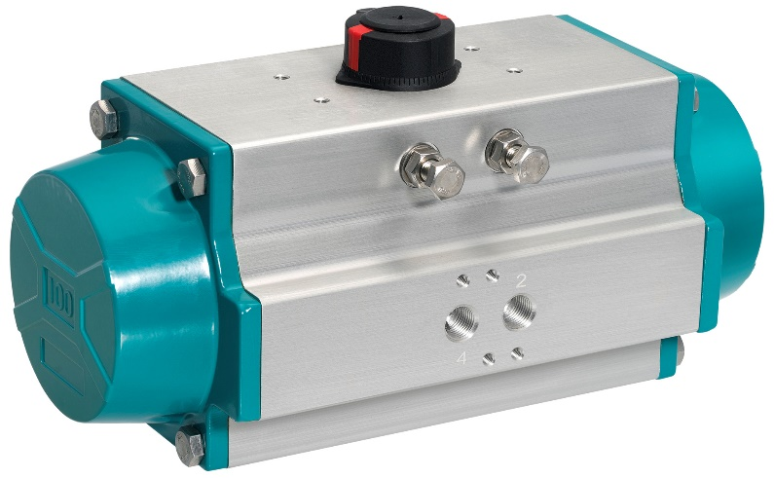
GEMÜ GDR pneumatic actuator for quarter turn valves

Background information

The GEMÜ Group develops and manufactures valves, measurement and control systems for liquids, vapours and gases. GEMÜ is a global market leader when it comes to solutions for sterile applications.
The globally focused, independent family-owned enterprise was founded in 1964. In 2011, Gert Müller took over as Managing Partner together with his cousin Stephan Müller, becoming the second generation to run the company. The Group achieved a turnover of over €330 million in 2019 and currently employs over 1900 members of staff worldwide, over 1100 of whom are in Germany. They have six manufacturing locations: Germany, Switzerland and France, as well as China, Brazil and the USA. Their worldwide marketing is carried out across 27 subsidiaries, coordinated from Germany. Thanks to a large network of commercial partners, GEMÜ is now active in over 50 countries on all continents.
Please visit www.gemu-group.com for further information.

