25th June 2020

Expanded range of motorized valves

Ingelfingen-based valve specialist GEMÜ is further expanding its product range of motorized globe, angle seat and diaphragm valves.

With immediate effect, the GEMÜ R629 eSyLite motorized diaphragm valve is also available in diaphragm sizes MG 10 and MG 40, covering nominal sizes DN 12 to 50. The GEMÜ eSyLite is available alongside the GEMÜ eSyStep and GEMÜ eSyDrive motorized valve range as a basic actuator for open/close applications in the entry-level segment. An optical position indicator and a manual override are installed as standard on the GEMÜ eSyLite, and an integrated emergency power supply module is optionally available. The GEMÜ R629 eSyLite motorized 2/2-way diaphragm valve is a cost-effective alternative to solenoid valves made of plastic or to motorized ball valves made of plastic. Due to the GEMÜ HighFlow body, the valve has good flow characteristics and is insensitive to particulate media. Furthermore, the GEMÜ eSyLite actuator can also be mounted on M-block valves.

The GEMÜ eSyStep universal actuator has also been extended by one size. This means that the GEMÜ 543 and 533 eSyStep globe valves are available in the nominal sizes DN 6 and 15 to 50 with immediate effect. In the future, the nominal size range from DN 4 to 32 will be covered with the GEMÜ 639 and R639 eSyStep diaphragm valves. Valves with the GEMÜ eSyStep actuator are available in open/close or positioner versions. An IO-Link interface allows process data and parameter data to be exchanged easily. This means they are perfect for both open/close applications and simple control applications. Thanks to its slim design, the GEMÜ eSyStep actuator is also perfect for use on M-block valves.

By expanding the range of motorized valves to additional nominal sizes, GEMÜ is further extending its offering of energy-efficient alternatives to compressed air systems.
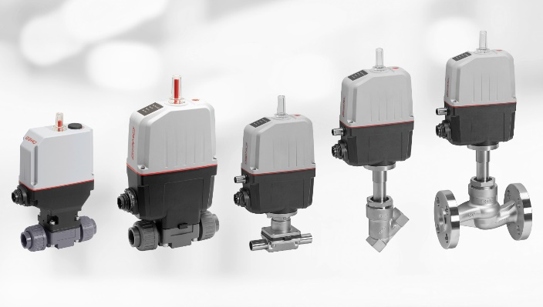

New motorized valves: GEMÜ R629 eSyLite and GEMÜ R639, 639, 543 and 533 eSyStep (left to right)

Background information

The GEMÜ Group develops and manufactures valves, measurement and control systems for liquids, vapours and gases. GEMÜ is a global market leader when it comes to solutions for sterile applications.
The globally focused, independent family-owned enterprise was founded in 1964. In 2011, Gert Müller took over as Managing Partner together with his cousin Stephan Müller, becoming the second generation to run the company. The Group achieved a turnover of over €330 million in 2019 and currently employs over 1900 members of staff worldwide, over 1100 of whom are in Germany. They have six manufacturing locations: Germany, Switzerland and France, as well as China, Brazil and the USA. Their worldwide marketing is carried out across 27 subsidiaries, coordinated from Germany. Thanks to a large network of commercial partners, GEMÜ is now active in over 50 countries on all continents.
Please visit www.gemu-group.com for further information.

