19th November 2020

Directly controlled process solenoid valve with innovative bellows system

Valve specialist GEMÜ is launching the new GEMÜ M75 process solenoid valve with pressure compensation.

This uses an innovative double bellows principle to compensate for pressure forces. This principle means that the new valve with the highly compact coil in the available nominal sizes can be used for processes with an operating pressure of up to 6 bar.
Solenoid valves are characterized by short operating times and are therefore ideal for dosing steps in mixing technology. Whether in the chemical industry, water treatment, washing and cleaning installations or in electroplating – solenoid valves are a low-maintenance alternative to pneumatic or motorized valves, which is also cost-effective in the smaller nominal sizes.
The new directly controlled, fully pressure-relieved GEMÜ M75 2/2-way process solenoid valve has a plastic encapsulated coil, available in a range of different supply voltages. The valve also helps to save resources thanks to an energy-saving reduction in holding current. Dynamic and static pressure forces are compensated for by the double bellows. Thanks to a wide range of high-quality body materials (PP, PVC and PVDF) and hermetic separation between the medium and the actuator using O-rings in various designs, the new process solenoid valve guarantees a reliable process sequence – including for corrosive media. The valve can also be used for gaseous and liquid media and is suitable for vacuum applications. The compact solenoid valve is suitable for nominal sizes DN 8 to 15 (and can be extended to DN 20 with an adapter) for open/close applications.

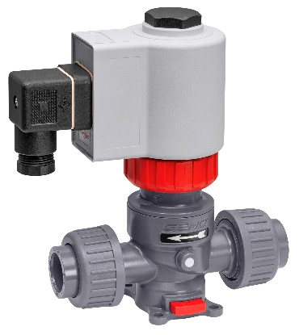

GEMÜ M75 pressure-compensated process solenoid valve

Background information

The GEMÜ Group develops and manufactures valves, measurement and control systems for liquids, vapours and gases. GEMÜ is a global market leader when it comes to solutions for sterile applications.
The globally focused, independent family-owned enterprise was founded in 1964. In 2011, Gert Müller took over as Managing Partner together with his cousin Stephan Müller, becoming the second generation to run the company. The Group achieved a turnover of over €330 million in 2019 and currently employs over 1900 members of staff worldwide, over 1100 of whom are in Germany. They have six manufacturing locations: Germany, Switzerland and France, as well as China, Brazil and the USA. Their worldwide marketing is carried out across 27 subsidiaries, coordinated from Germany. Thanks to a large network of commercial partners, GEMÜ is now active in over 50 countries on all continents.
Please visit www.gemu-group.com for further information.

