18th January 2021

Contactless and precise determination of the volumetric flow in systems and piping

GEMÜ, the manufacturer of valves, measurement and control systems, is bringing the new GEMÜ 3040 ultrasonic flowmeter the market which can be used to determine conductive and non-conductive volumetric flows of liquids in a contactless process.

The GEMÜ 3040 ultrasonic flowmeter is distinguished by its suitability for a wide range of nominal sizes (DN 10 to 50), its lack of moving parts in the media-wetted area and its increased accuracy and reproducibility of measurement results. The device can be used to measure both conductive and non-conductive media within a pressure range of 0 to 16 bar with an accuracy of 2% of the current measured value. The flowmeter can be used in a temperature range of between -10 °C and 80 °C.
Its high-quality plastic body means that the flowmeter can be used for corrosive media, such as acids and alkalis. Its use in cooling circuits, chemical processes and water supply projects make up just a small part of the GEMÜ 3040's diverse areas of application.
The illuminated display, which is installed as standard, means that programming can be carried out directly on-site. In addition, all of the important operating parameters can be read directly on the flowmeter and it comes with integrated empty pipe monitoring and a quantity measuring device as standard. In order to optimize integration into different applications, all of the standard electrical and mechanical connections are also provided.
As sensor systems are also often used in control circuits as part of process automation and monitoring, the GEMÜ 3040 measurement device can be combined with a GEMÜ valve and GEMÜ positioner or process controller to form a complete pressure control system.
With the launch of this ultrasonic flowmeter, GEMÜ is further expanding its product range of measurement systems. In addition, the GEMÜ C38 SonicLine ultrasonic flowmeter remains available for ultra pure applications.

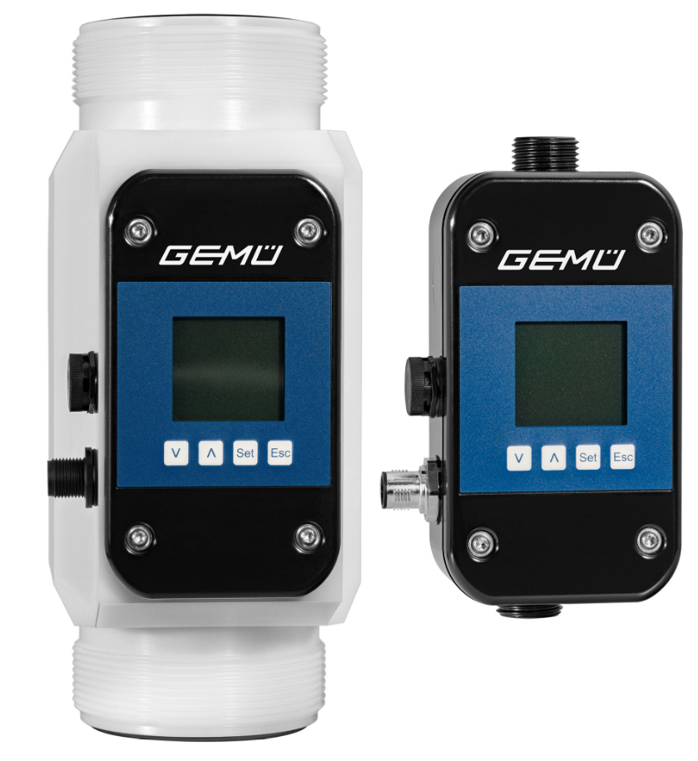
GEMÜ 3040 ultrasonic flowmeters

Background information

The GEMÜ Group develops and manufactures valves, measurement and control systems for liquids, vapours and gases. GEMÜ is a global market leader when it comes to solutions for sterile applications.
The globally focused, independent family-owned enterprise was founded in 1964. In 2011, Gert Müller took over as Managing Partner together with his cousin Stephan Müller, becoming the second generation to run the company. The Group achieved a turnover of over €330 million in 2020 and currently employs over 1900 members of staff worldwide, over 1100 of whom are in Germany. They have six manufacturing locations: Germany, Switzerland and France, as well as China, Brazil and the USA. Their worldwide marketing is carried out across 27 subsidiaries, coordinated from Germany. Thanks to a large network of commercial partners, GEMÜ is now active in over 50 countries on all continents.
Please visit www.gemu-group.com for further information.

