24th March 2020

GEMÜ F60 servoDrive for fast and precise filling

Featuring GEMÜ servoDrive actuator design, the GEMÜ F60 servoDrive filling valve is predestined for fast and precise filling of small volumes (approximately 1 ml to 100 ml), for sectors such as the pharmaceuticals industry.

Rotary lobe pumps are currently often used in hygienic and aseptic filling processes. Using the GEMÜ F60 servoDrive filling valve, developed by Ingelfingen-based valve specialist GEMÜ, not only allows these filling processes to be made significantly faster and more flexible, it also extends service lives.
The GEMÜ servoDrive actuator design excels through its high traverse speed, excellent positioning accuracy and fast controllability. The low-loss, brushless and robust servo motors made from stainless steel satisfy the requirements of electrical protection class IP69K and can achieve 50 to 100 million cycle duties, depending on the application.

An accuracy test was performed with the GEMÜ F60 servoDrive for filling with the smallest quantities. The aim here was to achieve the accuracy required when filling pharmaceuticals of ±0.5% at a filling weight of 1 g. The test was performed with water and a continuous pressure of 0.3 bar. The results showed that the requisite accuracy was delivered over multiple measurement series. Further tests with various small volumes also confirmed the filling accuracy. A filling cycle time of significantly less than one second could be achieved with all fill volumes. The GEMÜ F60 servoDrive allows faster filling cycles than the rotary lobe pumps that are currently often used. In addition, various filling volumes can be implemented without having to modify the filling plunger. Alongside filling of pharmaceutical products, the GEMÜ F60 servoDrive is also suitable for all filling applications that require accuracy, speed and hygiene, such as foodstuffs or battery and chemical filling.

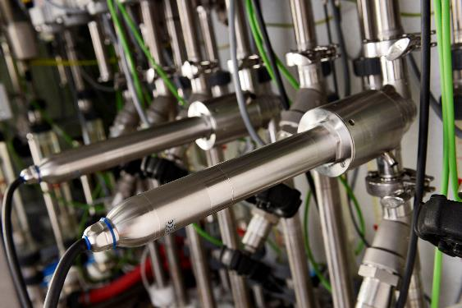

GEMÜ F60 servoDrive

Background information

The GEMÜ Group develops and manufactures valves, measurement and control systems for liquids, vapours and gases. GEMÜ is a global market leader when it comes to solutions for sterile applications.
The globally focused, independent family-owned enterprise was founded in 1964. In 2011, Gert Müller took over as Managing Partner together with his cousin Stephan Müller, becoming the second generation to run the company. The Group achieved a turnover of over €330 million in 2020 and currently employs over 1900 members of staff worldwide, over 1100 of whom are in Germany. They have six manufacturing locations: Germany, Switzerland and France, as well as China, Brazil and the USA. Their worldwide marketing is carried out across 27 subsidiaries, coordinated from Germany. Thanks to a large network of commercial partners, GEMÜ is now active in over 50 countries on all continents.
Please visit www.gemu-group.com for further information.

