9th March 2021

GEMÜ automation components receive UL certification mark

GEMÜ, the valve specialist, has had a further three of its intelligent automation components certified with UL approval: The GEMÜ 1235 and GEMÜ 1236 electrical position indicators and the GEMÜ 1436 eco cPos positioner.

The UL certification mark is valid for the USA and Canada. It is practically a prerequisite for all machines and plant components that are used or exported there.

GEMÜ 1235 and GEMÜ 1236 electrical position indicators
The GEMÜ 1235 and GEMÜ 1236 electrical position indicators are characterized by their compact and simple design, which still offers state-of-the-art functions. They feature the conventional discrete indication of the process valve position (closed or open) as well as IO-Link communication. The products are available in plastic and stainless steel.

GEMÜ 1436 eco cPos positioner
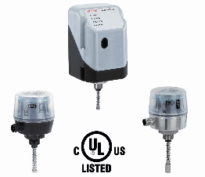
The GEMÜ 1436 eco cPos positioner is very versatile in use. The electronic system has been reduced to the core functions. Together with the quick commissioning function (speed-AP), this makes for a positioner that is incredibly easy to use and suitable for control tasks with basic requirements.
Caption: From left to right: GEMÜ 1234, GEMÜ 1436 eco cPos and GEMÜ 1235
Background information

The GEMÜ Group develops and manufactures valves, measurement and control systems for liquids, vapours and gases. GEMÜ is a global market leader when it comes to solutions for sterile applications.
The globally focused, independent family-owned enterprise was founded in 1964. In 2011, Gert Müller took over as Managing Partner together with his cousin Stephan Müller, becoming the second generation to run the company. The Group achieved a turnover of over €330 million in 2020 and currently employs over 1900 members of staff worldwide, over 1100 of whom are in Germany. They have six manufacturing locations: Germany, Switzerland and France, as well as China, Brazil and the USA. Their worldwide marketing is carried out across 27 subsidiaries, coordinated from Germany. Thanks to a large network of commercial partners, GEMÜ is now active in over 50 countries on all continents.
Please visit www.gemu-group.com for further information.

