1st August 2025

Certified safety: GEMÜ plastic diaphragm valves approved for the drinking water supply
GEMÜ plastic diaphragm valves are approved for use in any drinking water application in Germany with immediate effect. The basis for this is the successful examination and certification by the independent certification body OFI CERT in accordance with the current specifications of the German environmental protection agency (UBA).

For the installation and repair of drinking water systems, the UBA stipulates that only materials may be used that do not release any substances that pose a health risk to the drinking water or prohibit the growth of micro-organisms. As part of extensive testing, the plastic diaphragm valves from GEMÜ have been tested accordingly. The result is that valve types GEMÜ 610, 617, R629, R639, R647, R649, R677 and R690 with a PVC-U valve body and EPDM diaphragm meet all hygiene requirements.
GEMÜ therefore offers its customers tested safety and reliable product quality for use in cold and hot water applications for the drinking water supply.

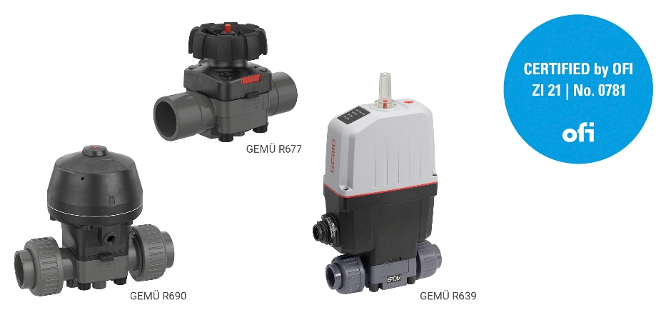

About us

The GEMÜ Group develops and manufactures valves, measurement and control systems for liquids, vapours and gases. GEMÜ is a global market leader when it comes to solutions for sterile applications.
The globally focused, independent family-owned enterprise was founded in 1964. In 2011, Gert Müller took over as Managing Partner together with his cousin Stephan Müller, becoming the second generation to run the company. In 2024, the group of companies achieved a turnover of over 525 million euros and currently employs more than 2,500 people worldwide, including around 1,400 in Germany. Production takes place at eight locations: In addition to the two production sites in Germany, GEMÜ manufactures its products in Brazil, China, France, India, Switzerland and the USA. Worldwide sales are handled by 25 subsidiaries and coordinated from Germany. GEMÜ is active in more than 50 countries on all continents via a dense network of trading partners.

Please visit www.gemu-group.com for further information.

