20th August 2021

New nominal sizes for GEMÜ 567 BioStar control, 567 eSyDrive and 567 servoDrive

GEMÜ, the valve specialist, offers his control valves GEMÜ 567 BioStar control, 567 eSyDrive and 567 servoDrive now in new nominal sizes.

The GEMÜ 567 BioStar control, 567 eSyDrive and 567 servoDrive control valves are designed for aseptic applications and are based on a unique sealing concept: PD design. This type of design has been developed by GEMÜ in order to unite the advantages of diaphragm valves with the advantages of globe valves. The valve's geometry allows for a hermetic separation of the actuator from the media flow and a high level of control accuracy. Quantities of 80 l/h right up to 63,000 l/h can be safely controlled, as well as batched quickly and precisely.
The GEMÜ 567 BioStar control, 567 eSyDrive and 567 servoDrive aseptic control valves are now available in nominal sizes DN 8 to DN 50.
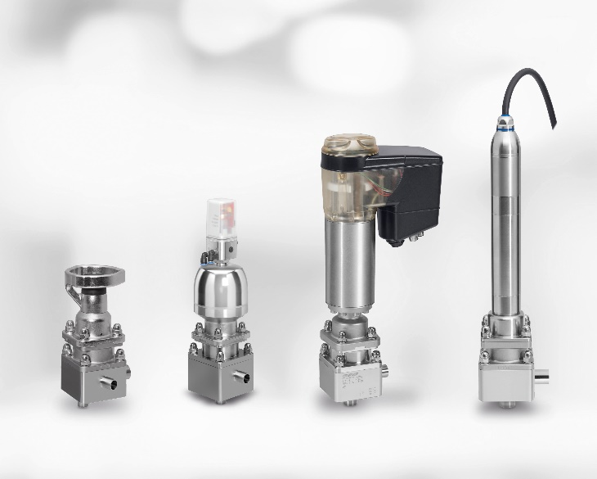
Control valves GEMÜ 567 BioStar control, manually and pneumatically operated, GEMÜ 567 eSyDrive und GEMÜ 567 servoDrive, motorized.

Background information

The GEMÜ Group develops and manufactures valves, measurement and control systems for liquids, vapours and gases. GEMÜ is a global market leader when it comes to solutions for sterile applications.
The globally focused, independent family-owned enterprise was founded in 1964. In 2011, Gert Müller took over as Managing Partner together with his cousin Stephan Müller, becoming the second generation to run the company. The Group achieved a turnover of over €330 million in 2020 and currently employs over 2000 members of staff worldwide, over 1100 of whom are in Germany. They have six manufacturing locations: Germany, Switzerland and France, as well as China, Brazil and the USA. Their worldwide marketing is carried out across 27 subsidiaries, coordinated from Germany. Thanks to a large network of commercial partners, GEMÜ is now active in over 50 countries on all continents.
Please visit www.gemu-group.com for further information.

