23rd September 2021

Two new diaphragms for demanding chemical applications

With the GEMÜ Code 71 and Code 5T diaphragms, the valve specialist GEMÜ is launching two new seals for diaphragm valves, which they developed in-house. Both seals are suitable for sophisticated processes in the chemical industry.

GEMÜ Code 71 three-layer PTFE/PVDF/EPDM diaphragm

The GEMÜ Code 71 three-layer diaphragm has been specially developed for use with corrosive and volatile media. It comprises a PTFE face, an intermediate layer made of PVDF and an EPDM backing. With regard to the PTFE face, the diaphragm is based on the tried-and-tested design and dimensions of the well-known Code 5M diaphragm. For applications with industrial gases, the additional PVDF intermediate layer offers excellent permeation properties. Thanks to the high-quality material selection, the diaphragm is resistant to corrosive chemicals such as volatile acids, oxidizing agents and salts, as well as humid chlorine, bromine and their derivatives.
The GEMÜ Code 71 diaphragm is available in diaphragm sizes 10 to 100 and is used in PFA-lined valve bodies from GEMÜ's product range.

GEMÜ Code 5T two-layer PTFE/FKM diaphragm

The GEMÜ Code 5T diaphragm is a two-layer diaphragm, comprising a PTFE face and an FKM backing. The PTFE that is used is a chemically modified second-generation PTFE, which is known as TFM™. The diaphragm has been developed for use in industrial applications, for example in the chemical industry, environmental engineering or the processing industry.
The GEMÜ Code 5T diaphragm is available in diaphragm sizes 10 to 100 and has a threaded pin that is sintered into place with integrated screw-in stop.
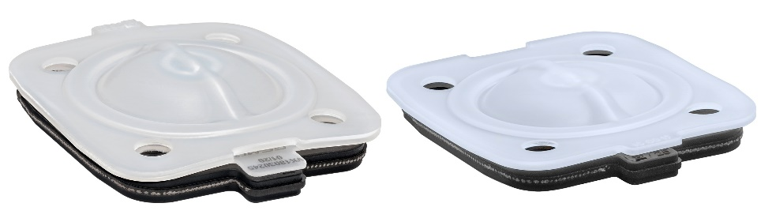
GEMÜ Code 71 and Code 5T diaphragms

Background information

The GEMÜ Group develops and manufactures valves, measurement and control systems for liquids, vapours and gases. GEMÜ is a global market leader when it comes to solutions for sterile applications.
The globally focused, independent family-owned enterprise was founded in 1964. In 2011, Gert Müller took over as Managing Partner together with his cousin Stephan Müller, becoming the second generation to run the company. The Group achieved a turnover of over €330 million in 2020 and currently employs over 2000 members of staff worldwide, over 1100 of whom are in Germany. They have six manufacturing locations: Germany, Switzerland and France, as well as China, Brazil and the USA. Their worldwide marketing is carried out across 27 subsidiaries, coordinated from Germany. Thanks to a large network of commercial partners, GEMÜ is now active in over 50 countries on all continents.
Please visit www.gemu-group.com for further information.

