02nd July 2021
Efficient maintenance of single-use diaphragm valves

The Ingelfingen-based valve specialist GEMÜ has further development his world´s first single-use diaphragm valve GEMÜ SUMONDO. It now enables even faster and more efficient maintenance of single-use systems.

Thanks to the newly developed, innovative connection concept of the actuator and body, putting the actuator in the open position is sufficient for a safe valve function. Then the unit conveying the media, comprising the valve body and internally welded diaphragm, only has to be connected to the actuator via a clamp ring. The valve is ready for use and can be operated.
Should the unit conveying the media be replaced, it is sufficient to open the valve, undo the clamp ring again and put the actuator in the closed position. The components can then simply be disconnected from each other.
The unit conveying the media does not change with the new connection concept. Components in stock can consequently be reused without limitations.
The new connection concept is available with immediate effect as a pneumatic design (GEMÜ SU40 SUMONDO) or as a motorized version (GEMÜ SU60 SUMONDO).
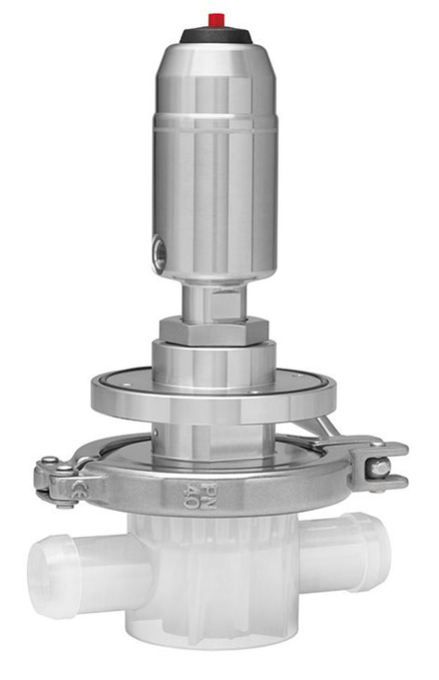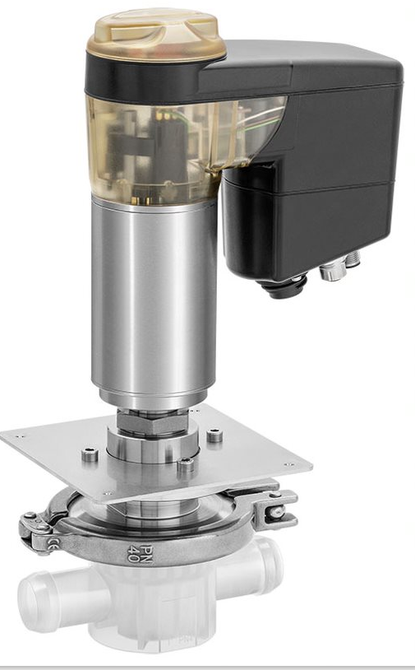
Pneumatic design GEMÜ SU40 SUMONDO and motorized version GEMÜ SU60 SUMONDO

Background information

The GEMÜ Group develops and manufactures valves, measurement and control systems for liquids, vapours and gases. GEMÜ is a global market leader when it comes to solutions for sterile applications.
The globally focused, independent family-owned enterprise was founded in 1964. In 2011, Gert Müller took over as Managing Partner together with his cousin Stephan Müller, becoming the second generation to run the company. The Group achieved a turnover of over €330 million in 2020 and currently employs over 1900 members of staff worldwide, over 1100 of whom are in Germany. They have six manufacturing locations: Germany, Switzerland and France, as well as China, Brazil and the USA. Their worldwide marketing is carried out across 27 subsidiaries, coordinated from Germany. Thanks to a large network of commercial partners, GEMÜ is now active in over 50 countries on all continents.
Please visit www.gemu-group.com for further information.

