09th December 2021

GEMÜ filling valve with regulating cone

The GEMÜ filling valves, also with regulating cone, are available now for even more precise dosing in filling processes.

Due to the constantly increasing varieties of beverages, liquid foodstuffs and pharmaceuticals, the filling process in the foodstuffs and pharmaceutical industry requires a huge variety of customized solutions.
For this reason, GEMÜ is now offering the GEMÜ F40 and F60 servoDrive filling valves with a regulating cone too. This means that the batch quantities of liquid, viscous and gaseous media can be batched more precisely, particularly for small volumes. The GEMÜ filling valves are equipped with an innovative PD design and are impressive with their speed, flexibility, resistance and precision.
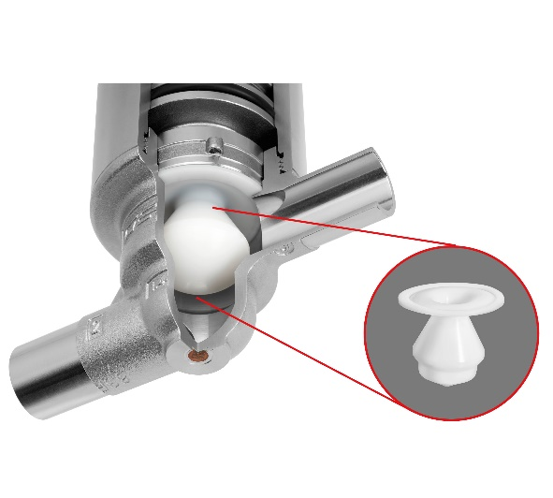
The GEMÜ F40 and F60 servoDrive filling valves are available in nominal sizes DN 8 to DN 25 with spigot or clamp connections according to DIN or ASME BPE. In addition to the investment casting valve bodies available to date, block material bodies are also now available, which can be electropolished upon request.
Background information

The GEMÜ Group develops and manufactures valves, measurement and control systems for liquids, vapours and gases. GEMÜ is a global market leader when it comes to solutions for sterile applications.
The globally focused, independent family-owned enterprise was founded in 1964. In 2011, Gert Müller took over as Managing Partner together with his cousin Stephan Müller, becoming the second generation to run the company. The Group achieved a turnover of over €330 million in 2020 and currently employs over 2100 members of staff worldwide, over 1200 of whom are in Germany. They have six manufacturing locations: Germany, Switzerland and France, as well as China, Brazil and the USA. Their worldwide marketing is carried out across 27 subsidiaries, coordinated from Germany. Thanks to a large network of commercial partners, GEMÜ is now active in over 50 countries on all continents.
Please visit www.gemu-group.com for further information.

