21st February 2022

2021 Trendsetter of German Economy

Ingelfingen-based technology company GEMÜ was named a "2021 Trendsetter of German Economy" by the F.A.Z. Institute and awarded second place in the measurement systems category.
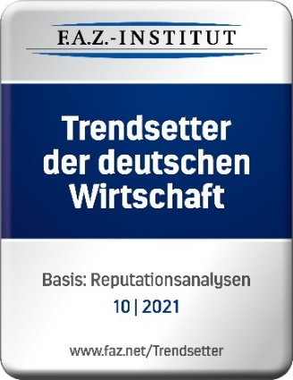
The F.A.Z. Institute bestows this accolade on companies who have demonstrated great success and pioneering spirit in aligning their strategic decisions and plans with global megatrends and thereby branching into new business areas.

To this end, the future-focused institute defined twelve megatrends – including health, mobility and even the "silver society", incorporating the effects of demographic change – that are having a long-term impact on the business areas companies operate in.

The F.A.Z. Institute, together with the IMWF Institute for Management and Economy Research, then assessed more than 20,000 companies and brands between August 2020 and July 2021 to establish how successful they were in aligning with megatrends. Scoring an impressive 96.8 out of a possible 100 points, GEMÜ won the second prize in the measurement systems category.

"The '2021 Trendsetter of German Economy' award motivates us to keep on developing new ideas, entering new markets and setting new trends. It is our goal to lead the way in developing innovative products and forward-thinking solutions in order to cement our long-term contribution to society and the economy," explains Gert Müller, Managing Partner of the GEMÜ Group.

About us

The GEMÜ Group develops and manufactures valves, measurement and control systems for liquids, vapours and gases. GEMÜ is a global market leader when it comes to solutions for sterile applications.
The globally focused, independent family-owned enterprise was founded in 1964. In 2011, Gert Müller took over as Managing Partner together with his cousin Stephan Müller, becoming the second generation to run the company. The Group achieved a turnover of over €450 million in 2021 and currently employs over 2200 members of staff worldwide, over 1200 of whom are in Germany. They have six manufacturing locations: Germany, Switzerland and France, as well as China, Brazil and the USA. Their worldwide marketing is carried out across 27 subsidiaries, coordinated from Germany. Thanks to a large network of commercial partners, GEMÜ is now active in over 50 countries on all continents.
Please visit www.gemu-group.com for further information.

