7th March 2022

GEMÜ is one of Germany's top employers for 2022

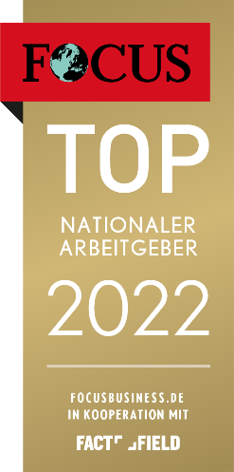
Once again, FOCUS-Business has listed the Hohenlohe-based technology company as one of Germany's top employers in the Industry category.

The fact that GEMÜ employees are very satisfied with their employer is reflected by the company's current ranking among the best 1000 employers, as revealed by FOCUS-Business on 19th February 2022.

The business magazine commissioned research institute FactField to conduct an online survey throughout Germany, analysing more than 550,000 online assessments of over 38,000 employers. This research concerned companies with a minimum of 500 employees, a site in Germany and an average rating of at least 3.5 stars from a minimum of 50 employee assessments. Using these criteria, the 1000 best employers in the country were chosen and listed in the FOCUS ranking by category.

Once again, the GEMÜ Group has been recognized as one of the country's top employers for 2022 in the Industry category. With approximately 1200 employees at three sites in the German state of Baden Württemberg, around 2200 employees worldwide and positive feedback from employees, the company met all of the criteria.

"We're delighted that GEMÜ has been listed as one of Germany's top employers again. This reaffirms our efforts to always advance our welcoming corporate culture. We believe that it's important that employees can successfully contribute and we can work together towards a common goal for the benefit of our customers," says Gert Müller, Managing Partner of the GEMÜ Group.

About us

The GEMÜ Group develops and manufactures valves, measurement and control systems for liquids, vapours and gases. GEMÜ is a global market leader when it comes to solutions for sterile applications.
The globally focused, independent family-owned enterprise was founded in 1964. In 2011, Gert Müller took over as Managing Partner together with his cousin Stephan Müller, becoming the second generation to run the company. The Group achieved a turnover of over €450 million in 2021 and currently employs over 2200 members of staff worldwide, over 1200 of whom are in Germany. They have six manufacturing locations: Germany, Switzerland and France, as well as China, Brazil and the USA. Their worldwide marketing is carried out across 27 subsidiaries, coordinated from Germany. Thanks to a large network of commercial partners, GEMÜ is now active in over 50 countries on all continents.
Please visit www.gemu-group.com for further information.

