30th August 2022

Safe solutions for combustible gases

The GEMÜ 550 angle seat globe valve from the Ingelfingen-based valve specialist GEMÜ is now available with gas approval in accordance with DVGW (German Technical and Scientific Association for Gas and Water).
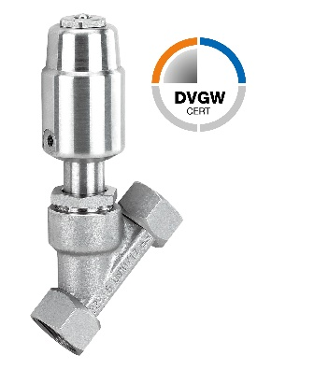
The GEMÜ 550 angle seat globe valve has been certified by the DVGW (German Technical and Scientific Association for Gas and Water) to DIN EN 161:2013-04 and DIN EN 16678:2016-02 standards. Therefore, the angle seat globe valve can be used as a shut-off valve for combustible gases in the gas families 2 and 3 in gas burners and gas appliances. Typical gases in this family include natural gases, petroleum gases and biogases, consisting mainly of methane, liquid gases containing propane and butane, and hydrogen.

The designs of the GEMÜ 550 angle seat globe valve that are suitable for use with combustible gases are those with the flow direction "over the seat". This does not result in the sealing force being reduced by the inlet pressure. The maximum operating pressure is 10 bar.

About us
The GEMÜ Group develops and manufactures valves, measurement and control systems for liquids, vapours and gases. GEMÜ is a global market leader when it comes to solutions for sterile applications.
The globally focused, independent family-owned enterprise was founded in 1964. In 2011, Gert Müller took over as Managing Partner together with his cousin Stephan Müller, becoming the second generation to run the company. The Group achieved a turnover of over €450 million in 2021 and currently employs over 2200 members of staff worldwide, over 1200 of whom are in Germany. They have six manufacturing locations: Germany, Switzerland and France, as well as China, Brazil and the USA. Their worldwide marketing is carried out across 28 subsidiaries, coordinated from Germany. Thanks to a large network of commercial partners, GEMÜ is now active in over 50 countries on all continents.
Please visit www.gemu-group.com for further information.

