1st March 2022

New variety of GEMÜ eSyLite motorized actuator
Expanded valve selection offers new opportunities in plant engineering

The valve specialist GEMÜ is expanding its valve selection for the GEMÜ eSyLite motorized actuator with three further valve types. With the larger selection of electrical valves, plant engineers and operators find a tailor-made solution even more easily.

In addition to the GEMÜ R629 eSyLite plastic diaphragm valve that already exists, the GEMÜ 629 diaphragm valve with stainless steel body and the GEMÜ 519 and 529 globe valves are now also available for simple, motorized open/close applications.

A total of four GEMÜ eSyLite valves now offers plant engineers and operators the opportunity of operating electrically driven plants more efficiently than before. In plants in which, for example, solenoid valves of large nominal sizes consume a relatively large amount of electricity, the GEMÜ globe valves from the eSyLite series are a cost-effective alternative. With low switching cycles and medium switching speed, they take on shut-off tasks just as precisely as solenoid valves, while at the same time scoring points when it comes to operating costs with their low electricity consumption. The GEMÜ eSyLite series also opens up new opportunities for plant optimization for applications where there have so far been no affordably priced alternatives to electrical ball valves. Automation with the new eSyLite valves, for example, can thus be further advanced. Where pneumatic valves could not previously be used, and manual valves were relied on instead, a motorized alternative is now available with which the plant can be automated cost-effectively.

The new valves complete the GEMÜ eSyLite series. The robust and self-locking motorized linear actuator has a safety switch-off function including overload protection. A manual override and an optical position indicator are integrated as standard. The valves are optionally available with the GEMÜ eSyLite actuator, with the GEMÜ 1215 electrical position indicator or with an integrated emergency power supply module.
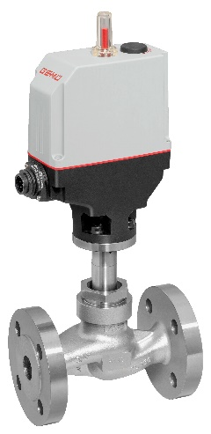

GEMÜ 519 eSyLite globe valve

About us

The GEMÜ Group develops and manufactures valves, measurement and control systems for liquids, vapours and gases. GEMÜ is a global market leader when it comes to solutions for sterile applications.
The globally focused, independent family-owned enterprise was founded in 1964. In 2011, Gert Müller took over as Managing Partner together with his cousin Stephan Müller, becoming the second generation to run the company. The Group achieved a turnover of over €450 million in 2021 and currently employs over 2200 members of staff worldwide, over 1200 of whom are in Germany. They have six manufacturing locations: Germany, Switzerland and France, as well as China, Brazil and the USA. Their worldwide marketing is carried out across 27 subsidiaries, coordinated from Germany. Thanks to a large network of commercial partners, GEMÜ is now active in over 50 countries on all continents.
Please visit www.gemu-group.com for further information.

