02nd February 2023

The GEMÜ 652 pulsation damper:
The hygienic solution to pressure surges in plants

The Ingelfingen-based valve specialist GEMÜ has developed the GEMÜ 652 pulsation damper. Based on its tried and tested diaphragm valve technology, it is also suitable for use in sterile applications. This means that it is completely drainable and CIP/SIP capable, taking the specified draining angle into account.

In many production plants, unwanted pressure surges arise which are generated by switching on pumps, by temperature changes in enclosed liquids or by quickly switching valves, for example. Opening valves can also result in pressure surges if the media supply is at a high level and the fluid column to lower plant components suddenly starts moving.
These pressure surges may damage plant components, such as filters, sensors, pumps and piping. Likewise, these pressure surges can result in shut-off valves briefly opening inadvertently. This can, in turn, result in possible contamination of the medium. In the worst case, they can result in downtime due to required repair work or a loss of product.

As a solution to this problem, GEMÜ has launched the GEMÜ 652 pulsation damper on the market. It is designed to open up as much volume as possible in a given operating range and thereby absorb and compensate for the pressure surge. Its body does not include a sealing weir, meaning that it is not suitable for shutting off media. The actual expansion volume is opened up by the moving diaphragm.
By using different actuator sizes and spring sets, it is possible to adjust the operating range and the volume that can be compensated for. Increased expansion volume can be achieved by installing multiple pulsation dampers in series.
The control air connector is only used for assembly. Actuation via control air is not required for operation, as its function is accomplished solely using spring force.

The GEMÜ 652 pulsation damper is available in the nominal sizes DN 15 to DN 80 (diaphragm size 25 to 80). To ensure high flexibility of applications, the valve bodies and diaphragms are available in various materials and designs. Due to the diaphragm valve technology used, the product complies as standard with the current standards in the foodstuffs and pharmaceutical industry, such as BSE/TSE, FDA, USP Class VI and Regulation (EC) no. 1935/2004.

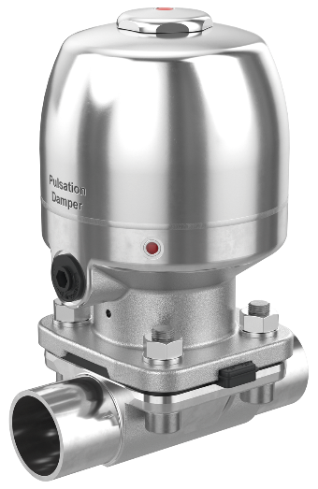

GEMÜ 652 pulsation damper

About us

The GEMÜ Group develops and manufactures valves, measurement and control systems for liquids, vapours and gases. GEMÜ is a global market leader when it comes to solutions for sterile applications.
The globally focused, independent family-owned enterprise was founded in 1964. In 2011, Gert Müller took over as Managing Partner together with his cousin Stephan Müller, becoming the second generation to run the company. The Group achieved a turnover of over €450 million in 2021 and currently employs over 2400 members of staff worldwide, over 1300 of whom are in Germany. They have six manufacturing locations: Germany, Switzerland and France, as well as China, Brazil and the USA. Their worldwide marketing is carried out across 27 subsidiaries, coordinated from Germany. Thanks to a large network of commercial partners, GEMÜ is now active in over 50 countries on all continents.
Please visit www.gemu-group.com for further information.

