29th August 2023

New solution for connecting multi-port valve blocks

Ingelfingen-based valve specialist GEMÜ is launching two new solutions for connecting single-use multi-port valve blocks.

The first solution means that it is now possible to control the pneumatic locking of the valve block via locking cylinders thanks to a valve block sunk into the skid surface. The second solution consists of using a valve block placed onto the skid surface, where the valve body is manually connected to the actuator unit via a detachable hand lever. This second type offers greater flexibility for the spigot layout. The connection between the actuator and the diaphragms welded onto the valve block is created reliably within a few seconds using the familiar clamping principle of the GEMÜ SU40 SUMONDO. The blocks themselves are produced by machining and can therefore be tailored to each specific application.

There are several benefits to using single-use technology: Eliminating the need for conventional cleaning cycles and the associated costs for power, cleaning media, waste disposal and peripherals while increasing protection against cross contamination between different manufacturing drives. It also minimises downtimes in factories, which significantly improves the flexibility and effectiveness of single-use solutions in the medical and pharmaceutical technology sectors in comparison with conventional solutions. In addition, the use of single-use technology reduces negative environmental effects by eliminating energy-intensive cleaning cycles.
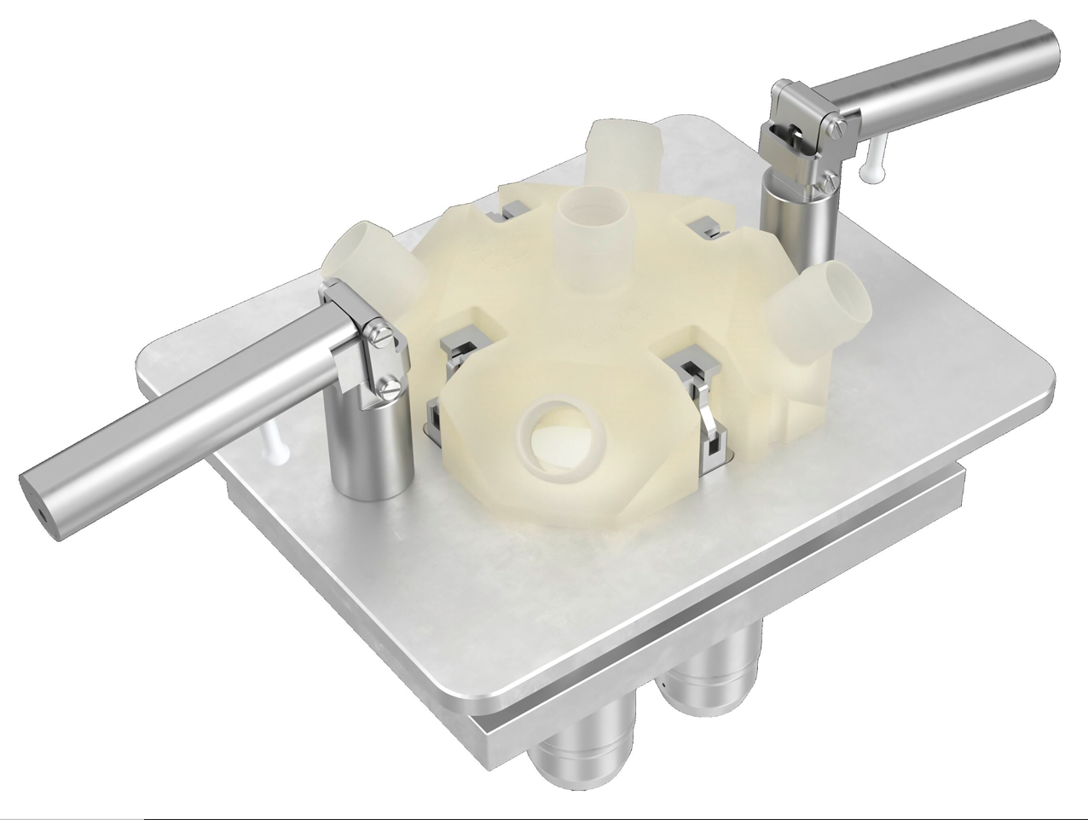

Single-use multi-port valve block with manual locking device

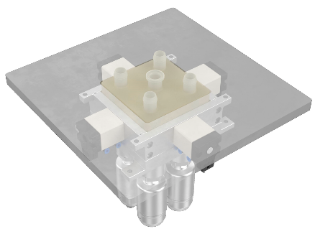

Single-use multi-port valve block with pneumatic locking device

About us

The GEMÜ Group develops and manufactures valves, measurement and control systems for liquids, vapours and gases. GEMÜ is a global market leader when it comes to solutions for sterile applications.
The globally focused, independent family-owned enterprise was founded in 1964. In 2011, Gert Müller took over as Managing Partner together with his cousin Stephan Müller, becoming the second generation to run the company. The Group achieved a turnover of over €530 million in 2022 and currently employs over 2400 members of staff worldwide, over 1300 of whom are in Germany. They have six manufacturing locations: Germany, Switzerland and France, as well as China, Brazil and the USA. Their worldwide marketing is carried out across 27 subsidiaries, coordinated from Germany. Thanks to a large network of commercial partners, GEMÜ is now active in over 50 countries on all continents.
Please visit www.gemu-group.com for further information.

