21st March 2023

The first GEMÜ high purity 3/2-way diaphragm globe valve

With the new GEMÜ C58 iComLine, the Ingelfingen-based technology company GEMÜ has developed its first 3/2-way diaphragm globe valve for ultra-pure applications. It has a supply and two possible outlets. It can also be operated in the opposite flow direction and the switch position can be detected via an optical position indicator.

For many years, the semiconductor industry has been successfully using the GEMÜ iComLine series all over the world. GEMÜ customers appreciate the numerous advantages of the design and the multitude of possible applications.
The new GEMÜ C58 iComLine 3/2-way process valve is suitable for ultra-pure and corrosive media. All media wetted parts are made of pure and highly resistant PTFE. The footprint/flow rate ratio is outstanding. This diaphragm globe valve is therefore particularly suited to applications in the process area and at the distribution level of semiconductor production.

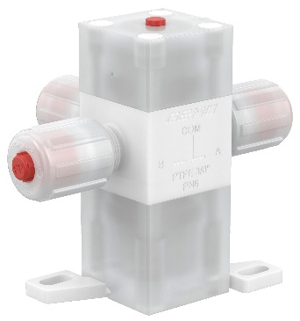
GEMÜ C58 iComLine

About us

The GEMÜ Group develops and manufactures valves, measurement and control systems for liquids, vapours and gases. GEMÜ is a global market leader when it comes to solutions for sterile applications.
The globally focused, independent family-owned enterprise was founded in 1964. In 2011, Gert Müller took over as Managing Partner together with his cousin Stephan Müller, becoming the second generation to run the company. The Group achieved a turnover of over €530 million in 2022 and currently employs over 2400 members of staff worldwide, over 1300 of whom are in Germany. They have six manufacturing locations: Germany, Switzerland and France, as well as China, Brazil and the USA. Their worldwide marketing is carried out across 27 subsidiaries, coordinated from Germany. Thanks to a large network of commercial partners, GEMÜ is now active in over 50 countries on all continents.
Please visit www.gemu-group.com for further information.

