20th December 2022

New electrically operated solenoid valve GEMÜ J70

Valve specialist GEMÜ is introducing the new GEMÜ J70 electrically operated 2/2-way solenoid valve, optimising its existing solenoid valve product group.

The GEMÜ J70 electrically operated solenoid valve is suitable for applications with low flow rates in analysis, vacuum and dosing technology and enables precise dosing. The resistant plug diaphragm made of PTFE (TFM™) has a unique sealing concept. PD technology provides for a high degree of accuracy for customer-specific applications.

With the PD (plug diaphragm) technology, the media wetted area is separated from the actuator by a plug diaphragm made from modified PTFE. PTFE is composed of linear carbon chains which are surrounded by fluorine atoms. They spatially shield the carbon atoms and protect the molecule from chemical attack – even at higher temperatures.
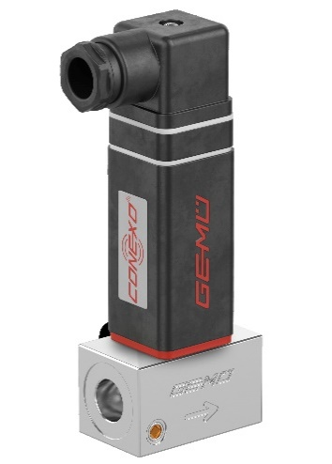
The compact GEMÜ J70 solenoid valve features a space-saving design and impressive features such as low wear and simple wear part replacement alongside good cleanability. The coil can be replaced without removing the valve body from the piping.

With CONEXO and an RFID chip, the GEMÜ J70 solenoid valve can be clearly identified, enabling efficient documentation of maintenance. In addition, the solenoid valve is variable and extendable and suitable for valve manifolds and multi-port valve blocks.

About us

The GEMÜ Group develops and manufactures valves, measurement and control systems for liquids, vapours and gases. GEMÜ is a global market leader when it comes to solutions for sterile applications.
The globally focused, independent family-owned enterprise was founded in 1964. In 2011, Gert Müller took over as Managing Partner together with his cousin Stephan Müller, becoming the second generation to run the company. The Group achieved a turnover of over €450 million in 2021 and currently employs over 2400 members of staff worldwide, over 1300 of whom are in Germany. They have six manufacturing locations: Germany, Switzerland and France, as well as China, Brazil and the USA. Their worldwide marketing is carried out across 27 subsidiaries, coordinated from Germany. Thanks to a large network of commercial partners, GEMÜ is now active in over 50 countries on all continents.
Please visit www.gemu-group.com for further information.

