18th November 2021

Modular M-block diaphragm valve with flexible connection system
The new GEMÜ P600S multi-port valve block solution allows for flexible combination of standardized single components. The new modular system therefore offers advantages regarding procurement and inventory-keeping, whilst simultaneously ensuring achievement of highly individual actuator travel and flow paths.

In addition to multi-port valve blocks manufactured on a case by case basis, today modular and partly standardized block systems made of plastic or stainless steel are already in use in many sectors. Thanks to the systematic construction of the modules, complex valve assemblies can be paired in a variable way based on fewer basic bodies, meaning complex actuator travel and flow paths can be produced with different layouts of basic bodies.
The new, innovative GEMÜ P600S M-block solution now goes one step further, facilitating later modification to connections via a flexible connection system, so that different types can be integrated individually into the respective processes.
The modular basic bodies and connections can be kept in stock as single components and paired depending on requirements on a case by case basis. GEMÜ thus provides plant engineers and operators with the option of flexibly adapting or expanding their process plants at any time directly on location.
GEMÜ P600S is available in various plastics as well as stainless steels.

GEMÜ P600S made of plastic for chemically corrosive media

With the plastic series of the new GEMÜ P600S, GEMÜ provides a multi-functional solution for blending, diverting, draining or feeding chemically corrosive media. The modular M-block diaphragm valve is available in materials PP-H and PVC, and in nominal sizes DN 8 to DN 25. Spigots, threaded sockets and union ends on the basic body can be adapted to individual requirements via the flexible connection system.

GEMÜ P600S in stainless steel for aseptic applications

With the stainless steel series of the new GEMÜ P600S, GEMÜ provides a multi-functional solution for blending, diverting, draining or feeding demanding media in the pharmaceutical industry, biotechnology industry and the food industry. The modular M-block diaphragm valve is available in various stainless steel materials, and in nominal sizes DN 20 to DN 25 – other versions are available on request. Spigots, flanges and clamps on the basic body can be adapted to individual requirements via the flexible connection system. The interfaces for individual components have been designed based on a standardized aseptic connection.

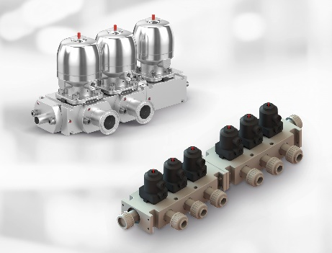

Background information
The GEMÜ Group develops and manufactures valves, measurement and control systems for liquids, vapours and gases. GEMÜ is a global market leader when it comes to solutions for sterile applications.
The globally focused, independent family-owned enterprise was founded in 1964. In 2011, Gert Müller took over as Managing Partner together with his cousin Stephan Müller, becoming the second generation to run the company.
The Group achieved a turnover of over €330 million in 2020 and currently employs over 2100 members of staff worldwide, over 1200 of whom are in Germany. They have six manufacturing locations: Germany, Switzerland and France, as well as China, Brazil and the USA. Their worldwide marketing is carried out across 27 subsidiaries, coordinated from Germany. Thanks to a large network of commercial partners, GEMÜ is now active in over 50 countries on all continents.

Please visit www.gemu-group.com for further information.

