17th January 2022

GEMÜ honoured as "Global Market Leader" for the sixth time in a row

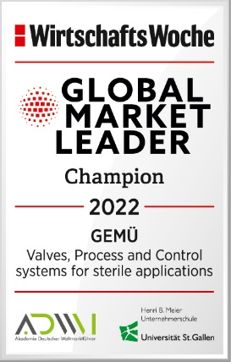
Ingelfingen-based technology company GEMÜ has once again been included in the global market leader index of the University of St. Gallen and the Academy of German Global Market Leaders and has been awarded the title of "Global Market Leader Champion 2022" by the WirtschaftsWoche business magazine

GEMÜ has been honoured as "Global Market Leader" in the sector of "Valves, process and control systems for sterile applications" for the sixth time in a row. Companies listed as "Global Market Leaders" in the global market leader index of the University of St. Gallen are first or second in at least one relevant market segment. Companies awarded the title of "Global Market Leader" must also be based at least partly in Germany or in the German-speaking part of Europe (Germany, Austria, Switzerland) and achieve at least 50 million euros of sales annually. At least 50% of these sales must be generated abroad and on at least three continents.
Technology company GEMÜ meets these requirements and has therefore been honoured as "Global Market Leader" in the sector of "Fittings and automation components: Valves, process and control systems for sterile applications".
The owner-managed family-owned business develops and manufactures valve, measurement and control systems for liquids, vapours and gases – with 2200 employees worldwide as well as 27 subsidiaries and six manufacturing sites in Germany, Switzerland, China, Brazil, France and the USA.
"Even in this challenging year of the coronavirus pandemic, our global strategy and our focus on innovative customer solutions have paid off. Throughout the entire GEMÜ Group, this has enabled us to grow and support our customers in the sector of "sterile processes" by providing them with innovative products for their pioneering solutions. We are delighted to receive the title of "Global Market Leader" once again and see this as motivation to continue investing in future technologies," states Gert Müller, Managing Partner at the GEMÜ Group.

About GEMÜ

The GEMÜ Group develops and manufactures valve, measurement and control systems for liquids, vapours and gases. GEMÜ is a global market leader when it comes to solutions for sterile applications. The globally focused, independent family-owned enterprise was founded in 1964. In 2011, Gert Müller took over as Managing Partner together with his cousin Stephan Müller, becoming the second generation to run the company.

The Group achieved a turnover of over 450 million euros in 2021 and currently employs over 2200 members of staff worldwide, approx. 1200 of whom are in Germany. There are six manufacturing locations: Germany, Switzerland and France, as well as China, Brazil and the USA. From Germany, we coordinate the global marketing with 27 subsidiaries. Thanks to a large network of commercial partners, GEMÜ is now active in over 50 countries on all continents.Please visit www.gemu-group.com for further information.

